***Ideation Phase***

***Brainstorm & Idea Prioritization Template***

|  |  |
| --- | --- |
| ***DATE*** | ***19 September 2022*** |
| ***TEAM ID*** | ***PNF2022FMID37002*** |
| ***PROJECT NAME*** | ***IOT-SMART FARMING*** |
| ***MAXIMUM MARKS*** | ***4 Mark*** |

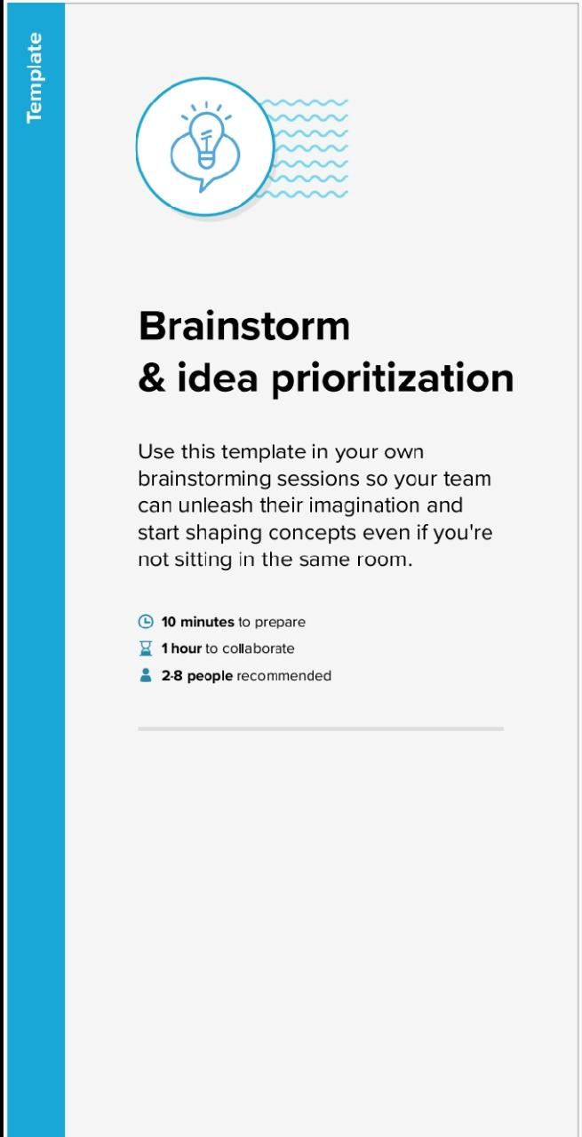

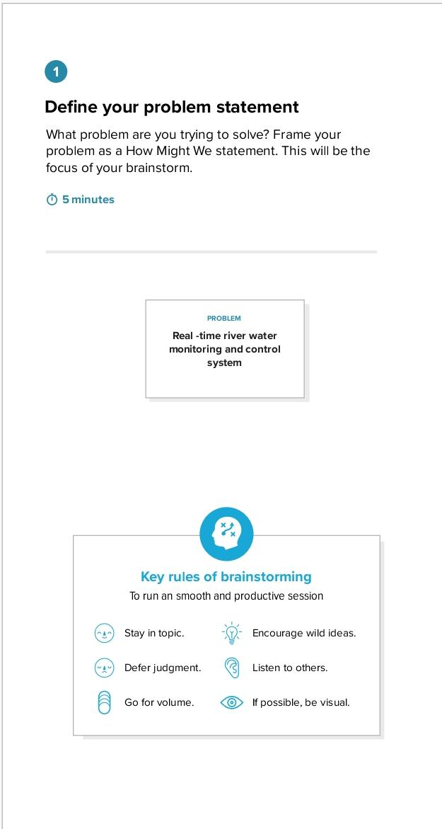

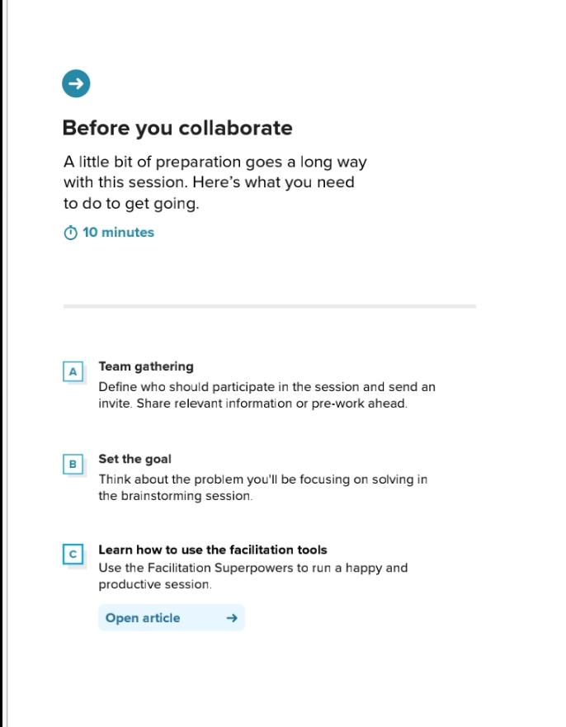

**Step-2: Brainstorm, Idea Listing and Grouping**

**Brainstorm**

Write down any ideas that come to mind

That address your problem statement.

10 minutes

Arunadevi sindhumathi suriyakala

Spectral image

Moisture sensor

Weather forecasting

Data analytics solutions

Software application

Sensing technologies

Weed and past management

Polyculture

Crop rotation

Suggest amount of fertilizers to be used

Provide better crop yield

Soil nutrition monitoring

Weather forecasting

Telematics, positioning technologies

Hardware and software system

pesticides

Biodynamic farming

Urban agriculture

Keep the data design

For scheduling watering of crops

Energy

Industry

Communications system

Water

Land

Climate effect

**stella**

Using in the real time application

Pesticides

Micro nutrient

Automation

Resource optimization

Quality food

Weather and geographical effect

Animals

Higher population

**Group ideas**

**Take turns sharing your ideas while clustering similar or related notes as you go. Once all sticky notes have been grouped, give each cluster a sentence-like label. If a cluster is bigger than six sticky notes, try and see if you and break it up into smaller sub-groups.**

**Data analiysis**

**Technique**

Water temperature indicates whether the water is cold or hot. The range of temperature sensor is 55 to +125°CWater temperature indicates whether the water is cold or hot. The range of temperature sensor is 55 to +125°C.

chlorine sensor is designed to measure the amount of chlorine in a solution.

Turbidity sensor can be used .It is a measure of cloudnes of water.

Flow sensor: Flow sensor is used to measure the flow of water.

**Sensor**

**20 minutes**

Evaluating effect of the substantial nutrient loads on overall

Water bcros cros validation can used.

the data mining techniques will be used for applying the

classification of the methods for water quality application. and data modeling to use the past dataset to inform the

future efforts of the EACH data needs to be in different of measures to analyse the quality

Using supervised learning algorithm, water quality class can be predicted.

each data needs to be iin different measures to beanalyse the quality.

Prioritize

Your team should all be on the same page about what's important

Moving forward. Place your ideas on this grid to determine which

ideas are important and which are feasible.

20 minutes

TEMPERATURE SENSOR

SUPER VISED LEARNING ALGORTHIM

PH SENSOR